Work flow:

Day1:

|  |  |  |
| --- | --- | --- |
| Feature1 | Pending work | Work done by: |
| Anurag bhaskhar | Make changes in file | Create a fork with main branch |
| Anushka singh | Make changes in file | Create a fork with main branch |
| Aprana | Make changes in file | Create new repositary |

Day 2:

|  |  |  |
| --- | --- | --- |
| Feature 2 | Pending work | Work done by: |
| Anurag bhaskhar | Create pull request | To work on google photo |
| Anushka singh | Create a pull request | To work in css code |
| Aprana | Accept fork request | To work in html code |

Day 3:

|  |  |  |
| --- | --- | --- |
| Feature 3 | Pending work | Workdone by: |
| Anurag bhaskhar | No pending work | Add readme file,add line |
| Anushka singh | No pending work | Addition in read me file |
| Aprana | No pending work | Addition in read me file |

Flow chat:

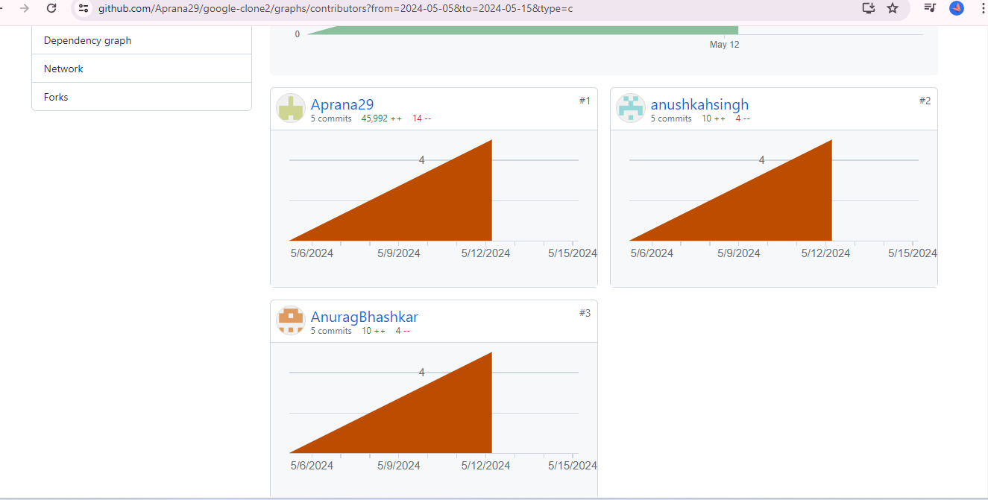

Uses and tags used in html/css: